Project title: Library Management System in Java
1. Aim
To develop a Library Management System using Java to demonstrate OOP concepts such as classes, objects, constructors, encapsulation, inheritance, polymorphism, abstraction, and interfaces.
2. System Requirements
- Hardware: Computer or laptop, minimum 4 GB RAM.
- Software: Windows/Linux operating system.
- Programming Language: Java.
- JDK: Java Development Kit (JDK 8 or above).
- IDE: Eclipse IDE or any Java editor.
- Execution: Command Prompt or Terminal.
3. Algorithm / Logic
- Start the program.
- Create a Book class with book ID, name, author, and price.
- Use default and parameterized constructors to initialize book details.
- Use private variables and getter/setter methods for encapsulation.
- Create Person, Student, and Faculty classes to demonstrate inheritance.
- Implement method overloading to calculate the areas of different shapes.
- Implement method overriding using Vehicle, Car, and Bike classes.
- Create an abstract Shape class and implement draw() in Circle and Rectangle.
- Create a Printable interface and implement it in the Report class.
- Create objects and display the details and results of each concept.
- Stop the program.
4. UML Diagram
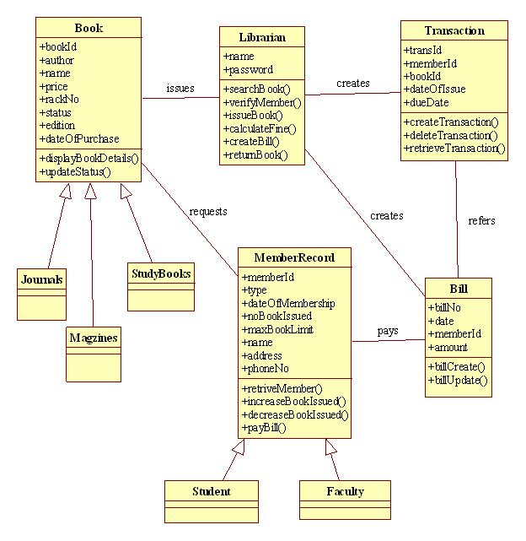
5. Source Code
class Book {
private int bookId;
private String bookName, author;
private double price;

// Default constructor
Book() {
bookId = 101;
bookName = "Java";
author = "James";
price = 450;
}

// Parameterized constructor
Book(int id, String name, String author, double price) {
this.bookId = id;
this.bookName = name;
this.author = author;
this.price = price;
}

public int getBookId() {
return bookId;
}

public String getBookName() {
return bookName;
}

public String getAuthor() {
return author;
}

public double getPrice() {
return price;
}

public void setPrice(double price) {
this.price = price;
}

void display() {
System.out.println("Book ID: " + bookId);
System.out.println("Book Name: " + bookName);
System.out.println("Author: " + author);
System.out.println("Price: " + price);
}
}

// Inheritance
class Person {
String name;

Person(String name) {
this.name = name;
}

void display() {
System.out.println("Name: " + name);
}
}

class Student extends Person {
Student(String name) {
super(name);
}

void show() {
System.out.println("Student: " + name);
}
}

class Faculty extends Person {
Faculty(String name) {
super(name);
}

void show() {
System.out.println("Faculty: " + name);
}
}

// Method overloading
class Area {
double calculate(double radius) {
return 3.14 * radius * radius;
}

double calculate(double length, double breadth) {
return length * breadth;
}
}

// Method overriding
class Vehicle {
void display() {
System.out.println("This is a vehicle");
}
}

class Car extends Vehicle {
@Override
void display() {
System.out.println("This is a car");
}
}

class Bike extends Vehicle {
@Override
void display() {
System.out.println("This is a bike");
}
}

// Abstraction
abstract class Shape {
abstract void draw();
}

class Circle extends Shape {
void draw() {
System.out.println("Drawing a circle");
}
}

class Rectangle extends Shape {
void draw() {
System.out.println("Drawing a rectangle");
}
}

// Interface
interface Printable {
void print();
}

class Report implements Printable {
public void print() {
System.out.println("Printing library report");
}
}

public class Main {
public static void main(String[] args) {
System.out.println("LIBRARY MANAGEMENT SYSTEM");

System.out.println("\n1. Classes and Objects");
Book b1 = new Book();
b1.display();

System.out.println("\nParameterized Constructor");
Book b2 = new Book(102, "C Programming",
"Dennis Ritchie", 350);
b2.display();

System.out.println("\n2. Encapsulation");
b2.setPrice(400);
System.out.println("Updated Price: " + b2.getPrice());

System.out.println("\n3. Inheritance");
Student s = new Student("Ravi");
Faculty f = new Faculty("Anita");
s.show();
f.show();

System.out.println("\n4. Method Overloading");
Area a = new Area();
System.out.println("Circle Area: " + a.calculate(5));
System.out.println("Rectangle Area: "
+ a.calculate(4, 6));

System.out.println("\n5. Method Overriding");
Vehicle v1 = new Car();
Vehicle v2 = new Bike();
v1.display();
v2.display();

System.out.println("\n6. Abstraction");
Shape sh1 = new Circle();
Shape sh2 = new Rectangle();
sh1.draw();
sh2.draw();

System.out.println("\n7. Interface");
Printable p = new Report();
p.print();
}
}
6. Compilation and Execution Commands
Open the terminal in the folder where Main.java is saved.
javac Main.java
java Main
7. Sample Output
LIBRARY MANAGEMENT SYSTEM

1. Classes and Objects
Book ID: 101
Book Name: Java
Author: James
Price: 450.0

Parameterized Constructor
Book ID: 102
Book Name: C Programming
Author: Dennis Ritchie
Price: 350.0

2. Encapsulation
Updated Price: 400.0

3. Inheritance
Student: Ravi
Faculty: Anita

4. Method Overloading
Circle Area: 78.5
Rectangle Area: 24.0

5. Method Overriding
This is a car
This is a bike

6. Abstraction
Drawing a circle
Drawing a rectangle

7. Interface
Printing library report
8. output
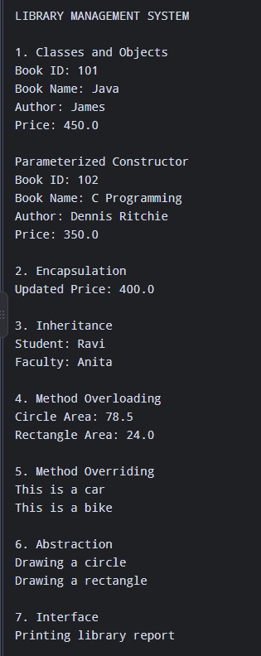

Result
Thus, the Library Management System was successfully implemented in Java. The program demonstrates classes, objects, constructors, encapsulation, inheritance, method overloading, method overriding, abstraction, and interfaces.

